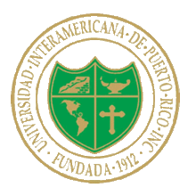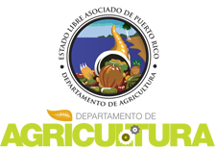 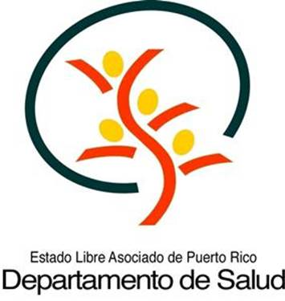

***Agenda***

**Reducing Pesticides in Puerto Rico**

FREE One day conference

Universidad Inter-American de Puerto Rico

Urbanizacion Industrial, Calle Federico Costa #170, Hato Rey, Puerto Rico

April 6th, 2016

8:30 AM – 5:00 PM**Universidad Interamericana de Puerto Rico,  
Facultad de Derecho  
Urb. Industrial,**

**Calle Federico Costa #170  
Hato Rey, Puerto Rico**

8:30 – 9:00 **Coffee, Registration and Networking**

9:00 – 9:30 **Keynote**

*Honorable Alejandro Garcia Padilla, Governor of Puerto Rico (invited)*

**Welcoming Remarks**

*Dr. Mirna Comas, Secretary, PR Department of Agriculture*

*Dr. Ana Rius, Secretary, PR Department of Health*

*Judith Enck, Regional Administrator Environmental Protection Agency*

9:30 -10:15 **Reducing use of Pesticides in Hotels/Restaurants/Schools**

*Dr. Jody Gangloff-Kaufmann, Cornell University*

10:15 – 10:30 **Networking Break**

10:30—11:15 **Reducing use of Pesticides in Homes**

Edward D. Freytag, Research Entomologist, The City of New Orleans, Mosquito, Termite and Rodent Control Board

***11:15 – 12:30*** ***Lunch on your own***

12:30 – 1:00 **Keynote Address: Health Impacts of Pesticide Exposure in Children and Adults**

*Dr. Philip Landrigan*

1:00 – 2:00 **Worker Protection Standards/Pesticide Worker Safety**

*TBD*

2:00 --3:00 **Zika Virus in Puerto Rico**

*Dr. Gredia Huertas*

3:00--3:15 **Break**

3:15--4:30 **ALL: Panel: the basis of a successful Integrated Pest Management Program**

*Facilitator: Claudia Gutierrez, EPA*

*Agro. Miguel Ortiz, PRDA, Agrologic Laboratory Director*

*Edward D. Freytag, Research Entomologist, The City of New Orleans*

*Dr. Jody Gangloff-Kaufmann, Cornell University*

*Dr. Carlos Carazo, PRDOH*

*Agro. Ada Alvarado, PRSEA*

4:30 – 5:00 **Where do we go from here? And follow up**

*Claudia Gutierrez, EPA*

5:00 **Adjourn and networking**

Meeting will be facilitated by Claudia Gutierrez, Senior Advisor to the Regional Administrator, EPA